Decagonal Prism
# Source: AI Source: Provided by: [Data Path: Persons Table -> ID Column: 1, Name_En Column: Motasem Essam] -> From: [ChatGPT] on [7/25/2026]
Solid Geometry - Types of Solids - Types of Prisms - Decagonal Prism

Definition
# Source: AI Source: Provided by: [Data Path: Persons Table -> ID Column: 1, Name_En Column: Motasem Essam] -> From: [ChatGPT] on [7/25/2026]
A decagonal prism is a three-dimensional polyhedron with two congruent, parallel decagonal bases connected by ten lateral faces.
Each decagonal base has ten sides and ten vertices. The ten lateral faces connect corresponding edges of the two bases, forming a closed solid.
A right decagonal prism has lateral edges perpendicular to the bases and rectangular lateral faces. An oblique decagonal prism has inclined lateral edges and parallelogram lateral faces.
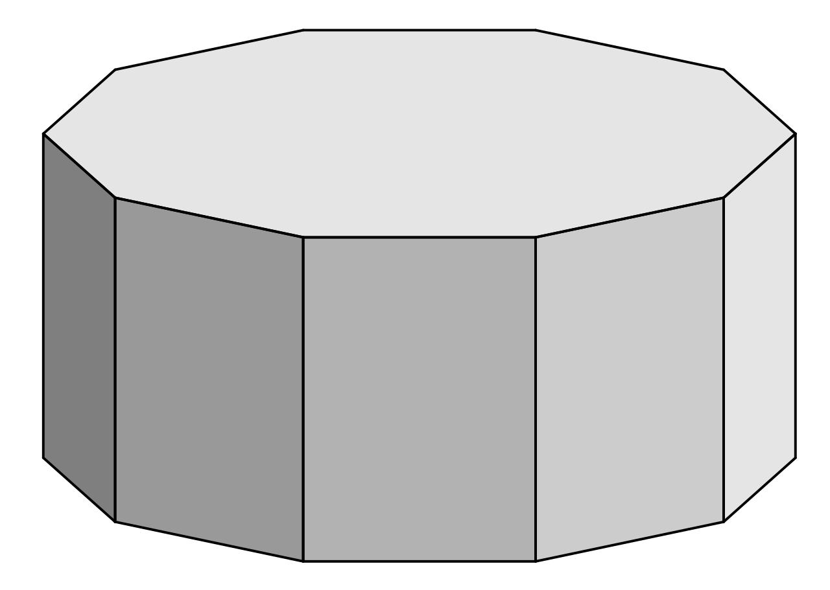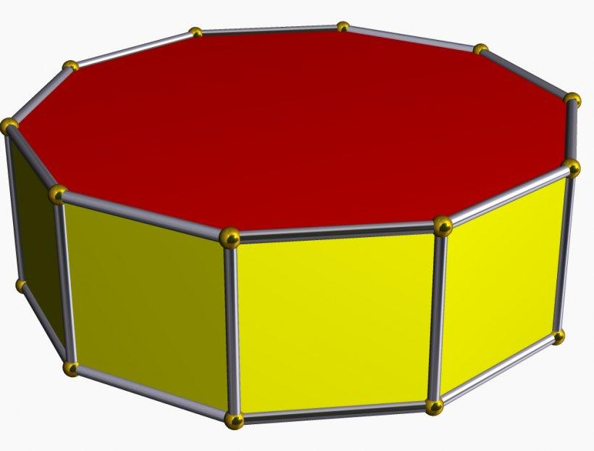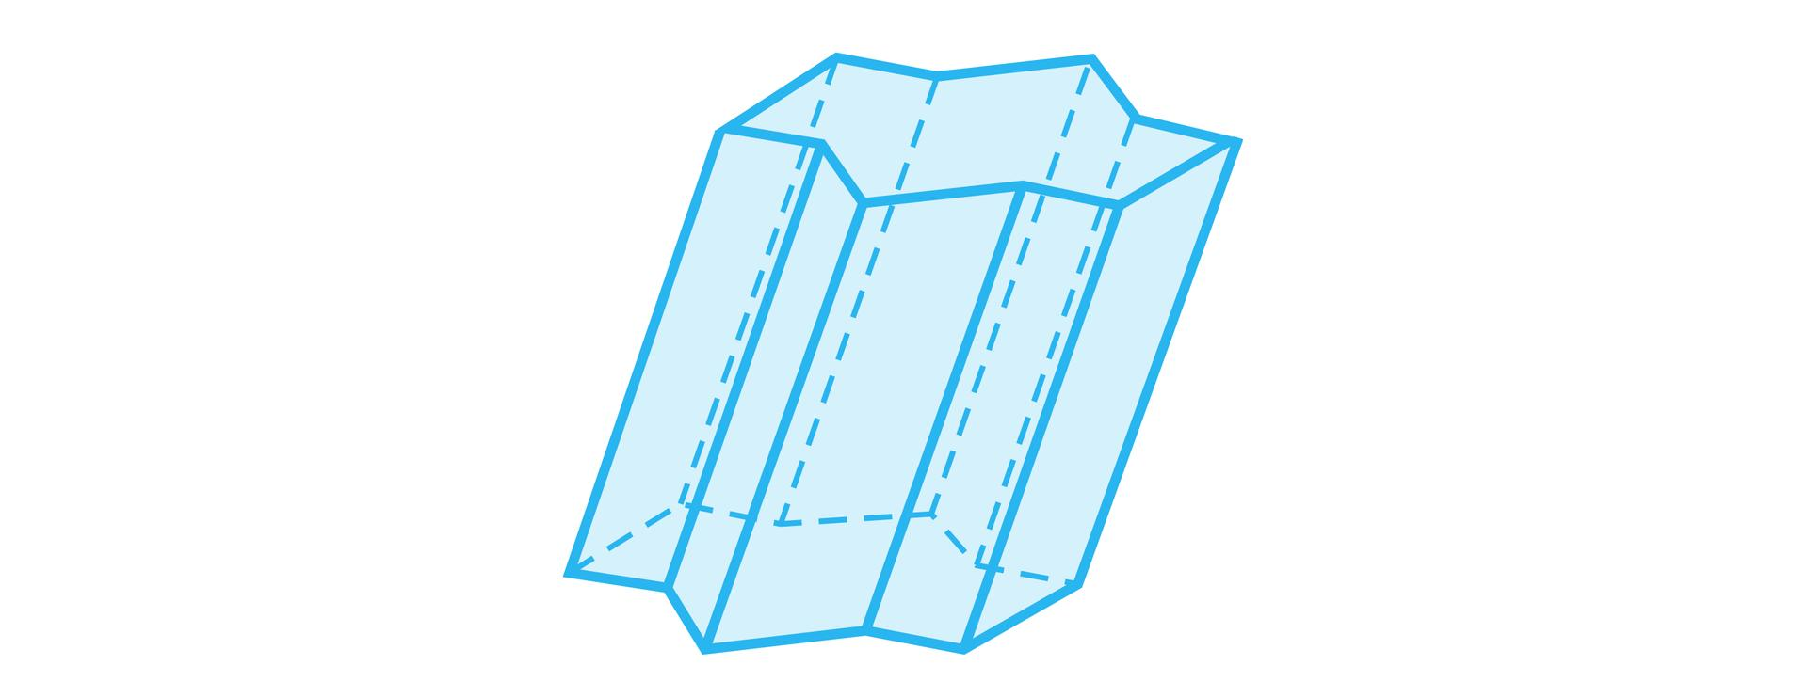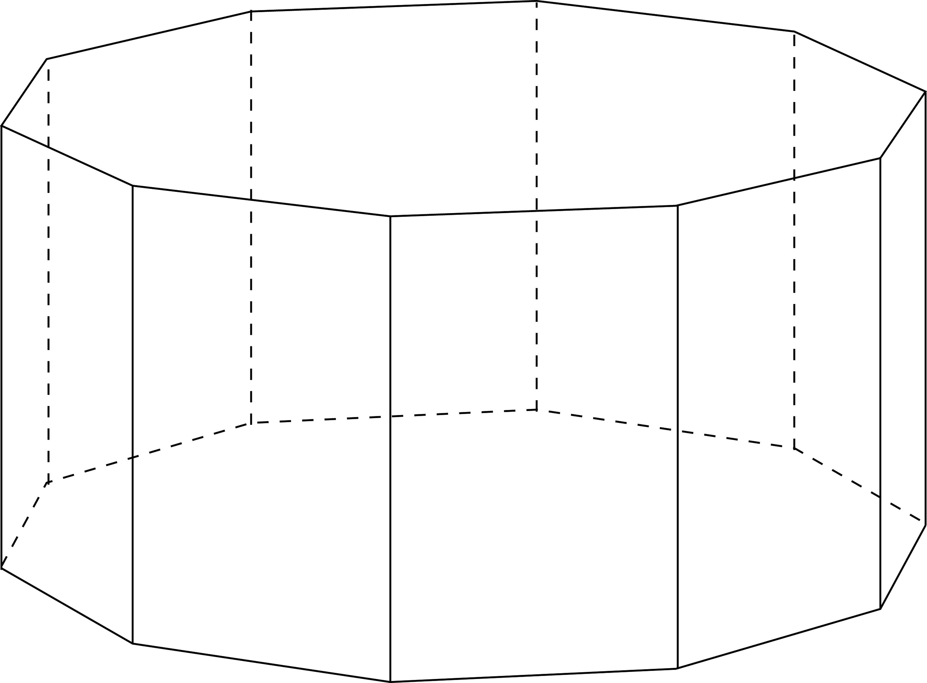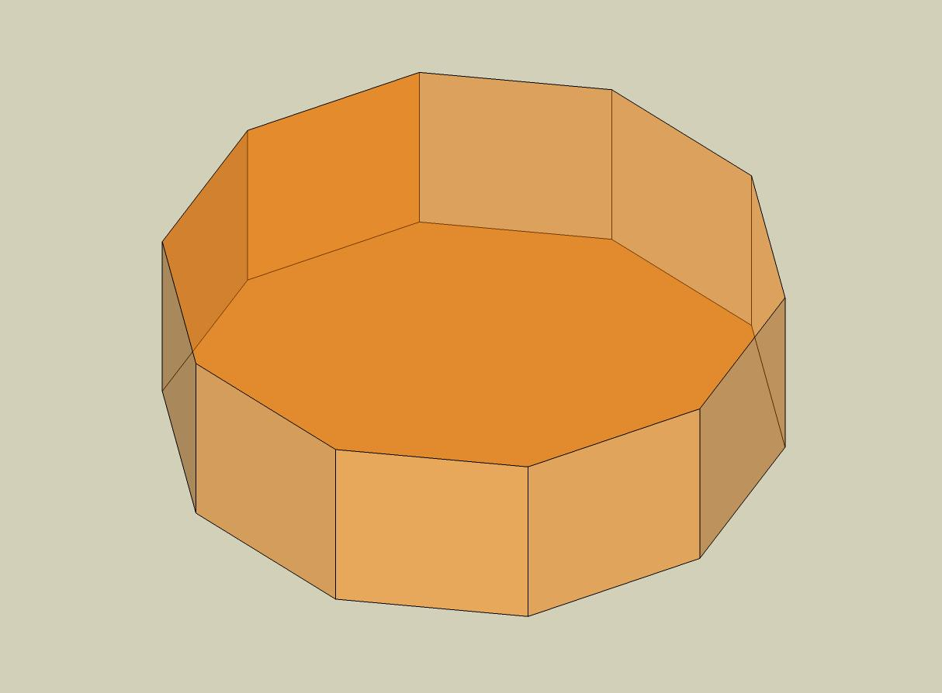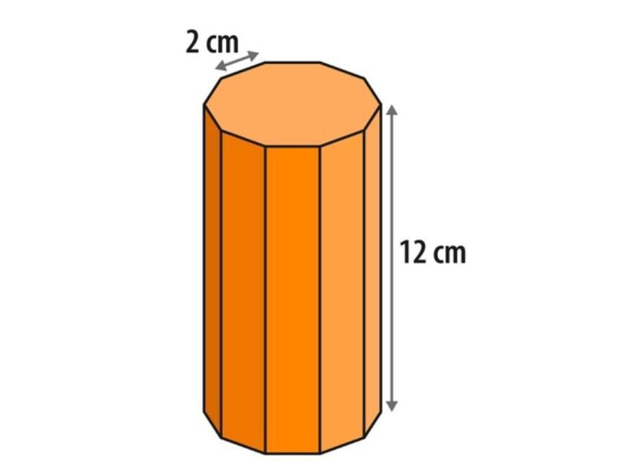

Simple Definition
# Source: AI Source: Provided by: [Data Path: Persons Table -> ID Column: 1, Name_En Column: Motasem Essam] -> From: [ChatGPT] on [7/25/2026]
A decagonal prism is a solid shape with two identical decagons at opposite ends and ten side faces.

Classification Tree
# Source: AI Source: Provided by: [Data Path: Persons Table -> ID Column: 1, Name_En Column: Motasem Essam] -> From: [ChatGPT] on [7/25/2026]
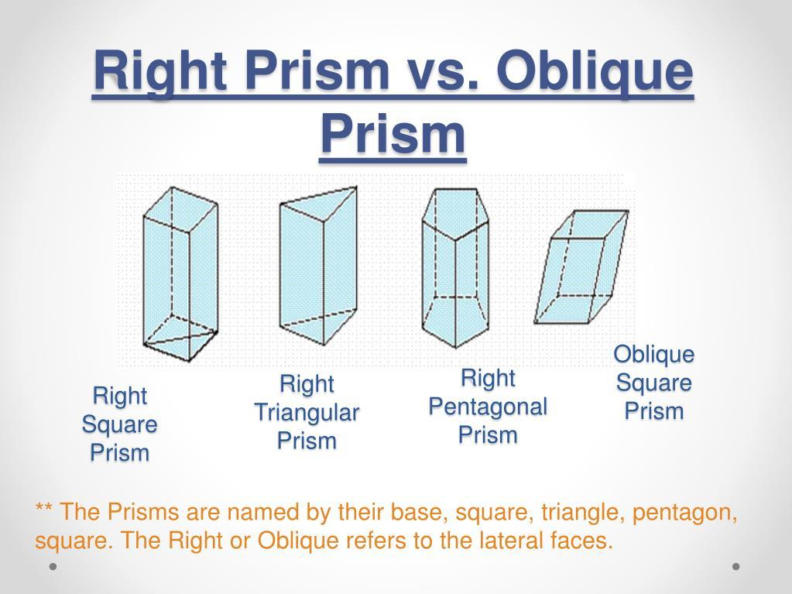
Right Decagonal Prism
Lateral edges are perpendicular to the bases.
Oblique Decagonal Prism
Lateral edges are inclined to the bases.
Regular-Base Prism
The bases are regular decagons.
Irregular-Base Prism
The bases are irregular decagons.
These classifications describe different properties. For example, a prism can be both right and regular-base. A regular decagonal prism conventionally has regular decagonal bases and perpendicular lateral edges.

Key Characteristics
# Source: AI Source: Provided by: [Data Path: Persons Table -> ID Column: 1, Name_En Column: Motasem Essam] -> From: [ChatGPT] on [7/25/2026]
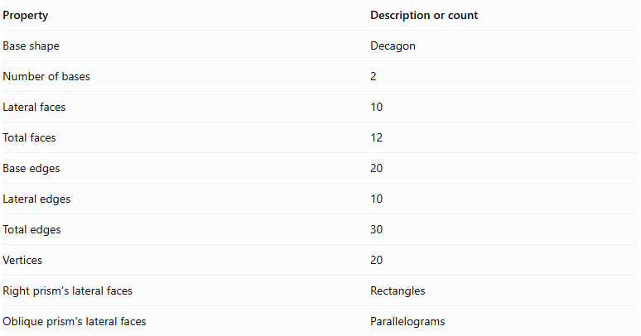
Property | Description or count
Base shape | Decagon
Number of bases | 2
Lateral faces | 10
Total faces | 12
Base edges | 20
Lateral edges | 10
Total edges | 30
Vertices | 20
Right prism's lateral faces | Rectangles
Oblique prism's lateral faces | Parallelograms

Geometric Representation
# Source: AI Source: Provided by: [Data Path: Persons Table -> ID Column: 1, Name_En Column: Motasem Essam] -> From: [ChatGPT] on [7/25/2026]
The main components of a decagonal prism are:
- Decagonal bases: The two congruent, parallel decagons.
- Lateral faces: The ten faces connecting the bases.
- Base edges: The twenty edges around the two decagonal bases.
- Lateral edges: The ten edges joining corresponding vertices of the bases.
- Vertices: The twenty corner points of the solid.
- Height: The perpendicular distance between the two base planes.
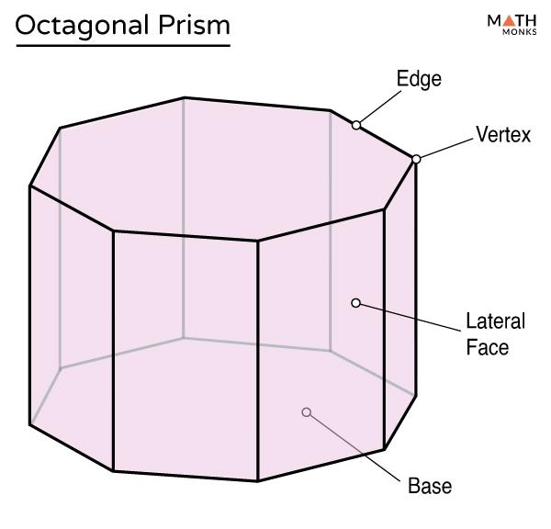

Mathematical Representations and Formulas
# Source: AI Source: Provided by: [Data Path: Persons Table -> ID Column: 1, Name_En Column: Motasem Essam] -> From: [ChatGPT] on [7/25/2026]
Let:
- $B$ = Area of one decagonal base.
- $P$ = Perimeter of one base.
- $h$ = Perpendicular height of the prism.
- $a$ = Side length of a regular decagonal base.
- $r$ = Apothem of a regular decagonal base.

A. Number of Faces, Edges, and Vertices
# Source: AI Source: Provided by: [Data Path: Persons Table -> ID Column: 1, Name_En Column: Motasem Essam] -> From: [ChatGPT] on [7/25/2026]
For a prism with an $n$-sided polygon as its base:
$$F=n+2$$
$$E=3n$$
$$V=2n$$
For a decagonal prism, $n=10$:
$$F=10+2=\boxed{12}$$
$$E=3(10)=\boxed{30}$$
$$V=2(10)=\boxed{20}$$

B. Area of a Regular Decagonal Base
# Source: AI Source: Provided by: [Data Path: Persons Table -> ID Column: 1, Name_En Column: Motasem Essam] -> From: [ChatGPT] on [7/25/2026]
For a regular decagon with side length $a$:
$$\boxed{B=\frac{10a^{2}}{4tan(π/10)}}$$
Simplifying:
$$\boxed{B=\frac{5a^{2}}{2tan({18}^{∘})}}$$
Its perimeter is:
$$\boxed{P=10a}$$
Alternatively, using the apothem:
$$\boxed{B=\frac{1}{2}Pr}$$
For a regular decagon, the apothem is:
$$\boxed{r=\frac{a}{2tan({18}^{∘})}}$$

C. Volume
# Source: AI Source: Provided by: [Data Path: Persons Table -> ID Column: 1, Name_En Column: Motasem Essam] -> From: [ChatGPT] on [7/25/2026]
The volume of any prism is its base area multiplied by its perpendicular height:
$$\boxed{V=Bh}$$
For a regular decagonal prism:
$$\boxed{V=\frac{5a^{2}h}{2tan({18}^{∘})}}$$

D. Lateral Surface Area
# Source: AI Source: Provided by: [Data Path: Persons Table -> ID Column: 1, Name_En Column: Motasem Essam] -> From: [ChatGPT] on [7/25/2026]
For a right decagonal prism:
$$\boxed{LSA=Ph}$$
Since for a regular decagon:
$$\boxed{LSA=10ah}$$
For an oblique prism, add the actual areas of its ten lateral parallelograms.

E. Total Surface Area
# Source: AI Source: Provided by: [Data Path: Persons Table -> ID Column: 1, Name_En Column: Motasem Essam] -> From: [ChatGPT] on [7/25/2026]
The total surface area includes the ten lateral faces and both bases:
$$\boxed{TSA=LSA+2B}$$
For a regular right decagonal prism:
$$\boxed{TSA=10ah+\frac{5a^{2}}{tan({18}^{∘})}}$$

Worked Examples

Example 1: Counting Faces, Edges, and Vertices
# Source: AI Source: Provided by: [Data Path: Persons Table -> ID Column: 1, Name_En Column: Motasem Essam] -> From: [ChatGPT] on [7/25/2026]
Problem: Find the number of faces, edges, and vertices of a decagonal prism.
Solution:
The base is a decagon, so $n=10$.
$$F=10+2=12$$
$$E=3(10)=30$$
$$V=2(10)=20$$
Answer: The prism has 12 faces, 30 edges, and 20 vertices.

Example 2: Calculating the Volume
# Source: AI Source: Provided by: [Data Path: Persons Table -> ID Column: 1, Name_En Column: Motasem Essam] -> From: [ChatGPT] on [7/25/2026]
Problem: A decagonal prism has a base area of $250{ cm}^{2}$ and a perpendicular height of $12 cm$. Find its volume.
Solution:
$$V=Bh$$
$$V=250×12$$
$$\boxed{V=3000{ cm}^{3}}$$

Example 3: Calculating the Area of a Regular Decagonal Base
# Source: AI Source: Provided by: [Data Path: Persons Table -> ID Column: 1, Name_En Column: Motasem Essam] -> From: [ChatGPT] on [7/25/2026]
Problem: A regular decagonal prism has a base side length of $4 cm$. Find the area of one base.
Solution:
Use the regular decagon area formula:
$$B=\frac{5a^{2}}{2tan({18}^{∘})}$$
Substitute $a=4$:
$$B=\frac{5(4)^{2}}{2tan({18}^{∘})}$$
$$B=\frac{80}{2tan({18}^{∘})}$$
$$\boxed{B≈123.11{ cm}^{2}}$$

Example 4: Calculating Total Surface Area
# Source: AI Source: Provided by: [Data Path: Persons Table -> ID Column: 1, Name_En Column: Motasem Essam] -> From: [ChatGPT] on [7/25/2026]
Problem: A regular right decagonal prism has a side length of $5 cm$ and a height of $10 cm$. Find its total surface area.
Step 1: Calculate the base perimeter.
$$P=10(5)=50 cm$$
Step 2: Calculate the lateral surface area.
$$LSA=Ph=50(10)=500{ cm}^{2}$$
Step 3: Calculate the area of one base.
$$B=\frac{5(5)^{2}}{2tan({18}^{∘})}$$
$$B≈192.36{ cm}^{2}$$
Step 4: Calculate the total surface area.
$$TSA=LSA+2B$$
$$TSA=500+2(192.36)$$
$$\boxed{TSA≈884.72{ cm}^{2}}$$

Example 5: Verifying Euler's Formula
# Source: AI Source: Provided by: [Data Path: Persons Table -> ID Column: 1, Name_En Column: Motasem Essam] -> From: [ChatGPT] on [7/25/2026]
Euler's formula for a convex polyhedron is:
$$V-E+F=2$$
For a decagonal prism:
$$20-30+12=2$$
Therefore, the decagonal prism satisfies Euler's formula.

Comparison with Related Prisms
# Source: AI Source: Provided by: [Data Path: Persons Table -> ID Column: 1, Name_En Column: Motasem Essam] -> From: [ChatGPT] on [7/25/2026]
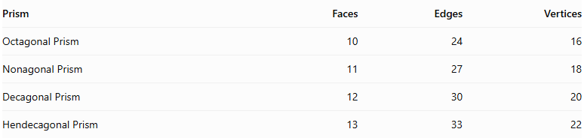
Prism | Faces | Edges | Vertices
Octagonal Prism | 10 | 24 | 16
Nonagonal Prism | 11 | 27 | 18
Decagonal Prism | 12 | 30 | 20
Hendecagonal Prism | 13 | 33 | 22
As the number of sides of the polygonal base increases by one, the prism gains one lateral face, three edges, and two vertices.

Constructing Decagonal Prism in Solid Geometry

Instruments Used
# Source: AI Source: Provided by: [Data Path: Persons Table -> ID Column: 1, Name_En Column: Motasem Essam] -> From: [ChatGPT] on [7/25/2026]
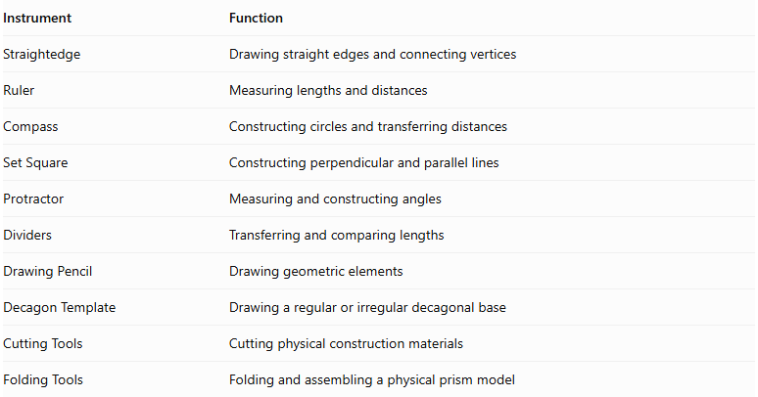
Instrument | Function
Straightedge | Drawing straight edges and connecting vertices
Ruler | Measuring lengths and distances
Compass | Constructing circles and transferring distances
Set Square | Constructing perpendicular and parallel lines
Protractor | Measuring and constructing angles
Dividers | Transferring and comparing lengths
Drawing Pencil | Drawing geometric elements
Decagon Template | Drawing a regular or irregular decagonal base
Cutting Tools | Cutting physical construction materials
Folding Tools | Folding and assembling a physical prism model

Construction Procedures

Right Decagonal Prism Construction
# Source: AI Source: Provided by: [Data Path: Persons Table -> ID Column: 1, Name_En Column: Motasem Essam] -> From: [ChatGPT] on [7/25/2026]
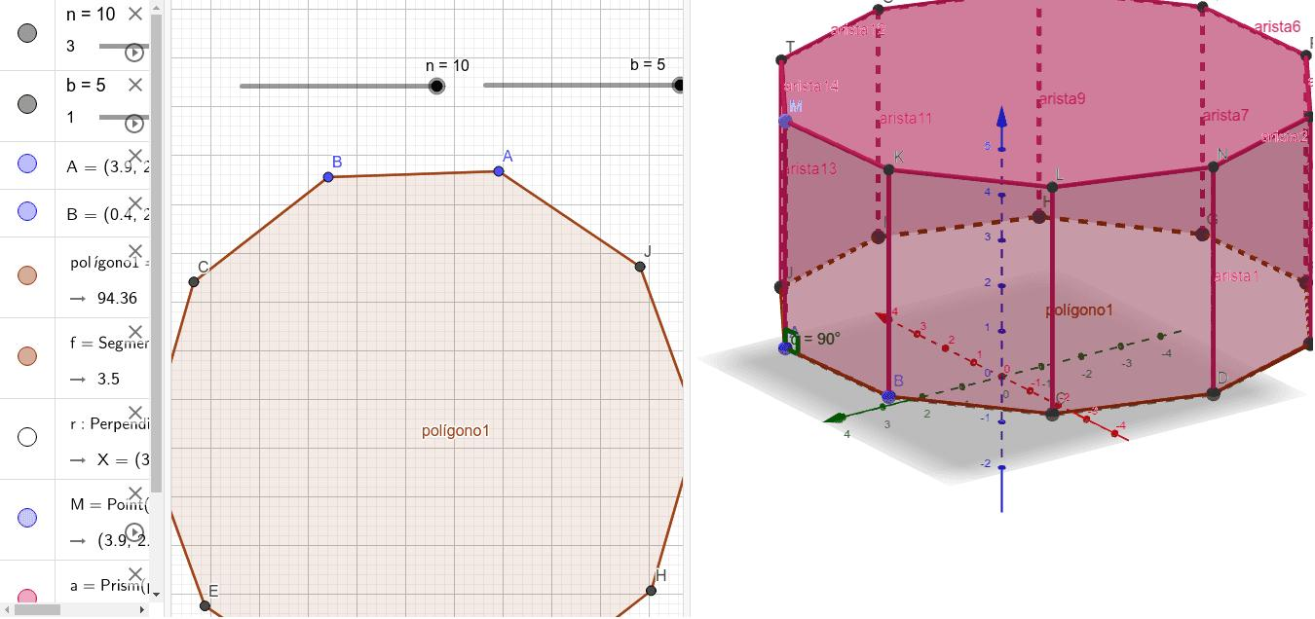
- Construct a decagonal base using geometric instruments.
- Determine the required perpendicular height.
- Construct a second decagon congruent to the first.
- Position the second base parallel to the first.
- Ensure that corresponding vertices are aligned along perpendicular lateral edges.
- Connect the corresponding vertices of both bases.
- Complete the ten rectangular lateral faces.
- Identify the visible and hidden edges to complete the geometric representation.

Oblique Decagonal Prism Construction
# Source: AI Source: Provided by: [Data Path: Persons Table -> ID Column: 1, Name_En Column: Motasem Essam] -> From: [ChatGPT] on [7/25/2026]
- Construct the first decagonal base.
- Determine the required direction and inclination of the lateral edges.
- Construct a second decagon congruent to the first in a parallel plane.
- Displace the second base in the selected oblique direction.
- Connect corresponding vertices using parallel lateral edges of equal length.
- Complete the ten parallelogram lateral faces.
- Identify the visible and hidden edges.

Net-Based Construction
# Source: AI Source: Provided by: [Data Path: Persons Table -> ID Column: 1, Name_En Column: Motasem Essam] -> From: [ChatGPT] on [7/25/2026]
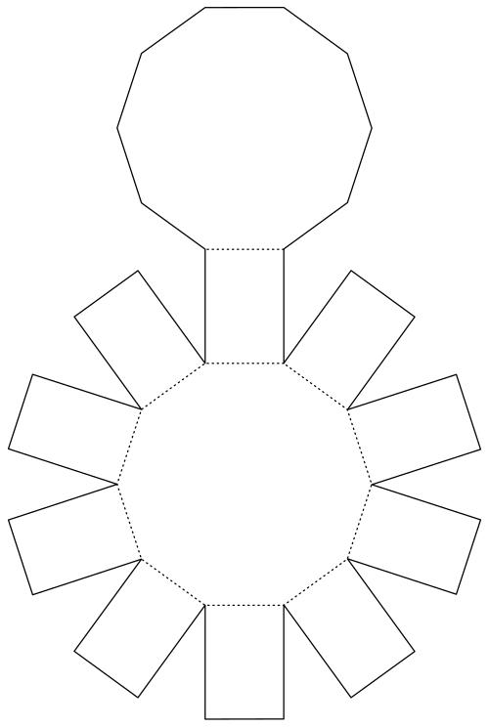
- Construct two congruent decagonal bases.
- Draw ten connected lateral faces.
- Arrange the lateral faces in a strip.
- Add the two decagonal bases in suitable positions.
- Add joining tabs if required for physical assembly.
- Cut out the net.
- Fold the lateral faces and attach the two bases.

Extrusion-Based Construction
# Source: AI Source: Provided by: [Data Path: Persons Table -> ID Column: 1, Name_En Column: Motasem Essam] -> From: [ChatGPT] on [7/25/2026]
- Construct a decagonal base.
- Establish a straight translation direction.
- Transfer the decagonal boundary along that direction.
- Construct the translated congruent decagon.
- Connect corresponding vertices.
- Complete the lateral faces to form the prism.

Applications of Decagonal Prisms
# Source: AI Source: Provided by: [Data Path: Persons Table -> ID Column: 1, Name_En Column: Motasem Essam] -> From: [ChatGPT] on [7/25/2026]
Decagonal prisms can appear in several practical and mathematical settings:
- Architecture: Ten-sided columns, pillars, and structural components.
- Engineering: Ten-sided structural components and geometric models.
- Product Design: Objects with decagonal cross-sections.
- Education: Demonstrating faces, edges, vertices, surface area, and volume.
- Computer Graphics: Representing three-dimensional polygonal objects.

Key Points
# Source: AI Source: Provided by: [Data Path: Persons Table -> ID Column: 1, Name_En Column: Motasem Essam] -> From: [ChatGPT] on [7/25/2026]
- A decagonal prism has two congruent, parallel decagonal bases.
- It has ten lateral faces and twelve faces in total.
- It has 30 edges and 20 vertices.
- Its volume is $V=Bh$.
- For a right prism, its lateral surface area is $LSA=Ph$.
- Its total surface area is $TSA=LSA+2B$.
- The area of a regular decagonal base is $B=\frac{5a^{2}}{2tan({18}^{∘})}$.
- It satisfies Euler's formula $V-E+F=2$.

Conclusion
# Source: AI Source: Provided by: [Data Path: Persons Table -> ID Column: 1, Name_En Column: Motasem Essam] -> From: [ChatGPT] on [7/25/2026]
A decagonal prism is a polyhedron with two congruent, parallel decagonal bases joined by ten lateral faces. It has twelve faces, thirty edges, and twenty vertices, making it a useful example of a prism with a ten-sided polygonal base.
Its volume is calculated by multiplying the base area by the perpendicular height, while its total surface area is the sum of the lateral surface area and the areas of both bases. For a regular decagonal prism, the base area can be calculated directly from its side length using:
$$B=\frac{5a^{2}}{2tan({18}^{∘})}$$
Understanding the decagonal prism extends the general rules for polygonal prisms and helps explain how the number of sides of a base determines a solid's faces, edges, and vertices.

